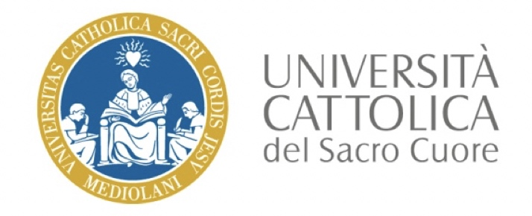

Italian Society of Soil Science
School of Soil Biodiversity and Bioindication (XII cycle)
SOIL MANAGEMENT AND QUALITY IN THE ERA OF AGRICULTURE SUSTAINABLE INTENSIFICATION

Registration form
Send it by email to segretario@scienzadelsuolo.org and eren.taskin@unicatt.it within 5th June 2020, with the following email subject: Registration_form_SISSBioBioSchool2020_Surname_Name

Surname
Name
Current position
Affiliation
Email address
Telephone
Brief curriculum vitae (Max 250 words; Font: Calibri 11)

Motivation for attending the school (Max 50 words; Font: Calibri 11)

Software skills in statistical analysis and manipulation of big data sets

Main research interests (e.g., thesis titles for PhD students, projects involvement for post-docs)

