CONFERENCE PARTICIPANT APPLICATION
«REFLECTION OF BIO-, GEO-, ANTROPOSPHERIC INTERACTIONS
IN SOILS AND SOIL COVER»

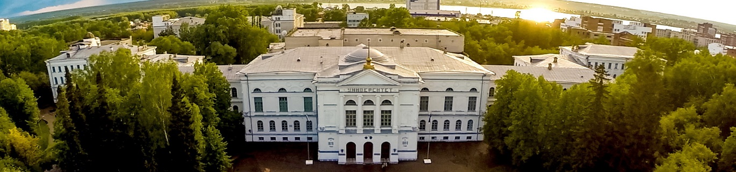

1. First name and Surname
2. Position, degree
4. Name of the institution with mail address
5. Phone number (with country and city code)
6. E-mail
7. Form of participation (oral presentation, poster, without report)
8. Article and presentation title
9. Conference topic (1- 4) as listed above
10. Participation in a scientific-field workshop
11. Need in an invitation
12. Your comments and/or suggestions

